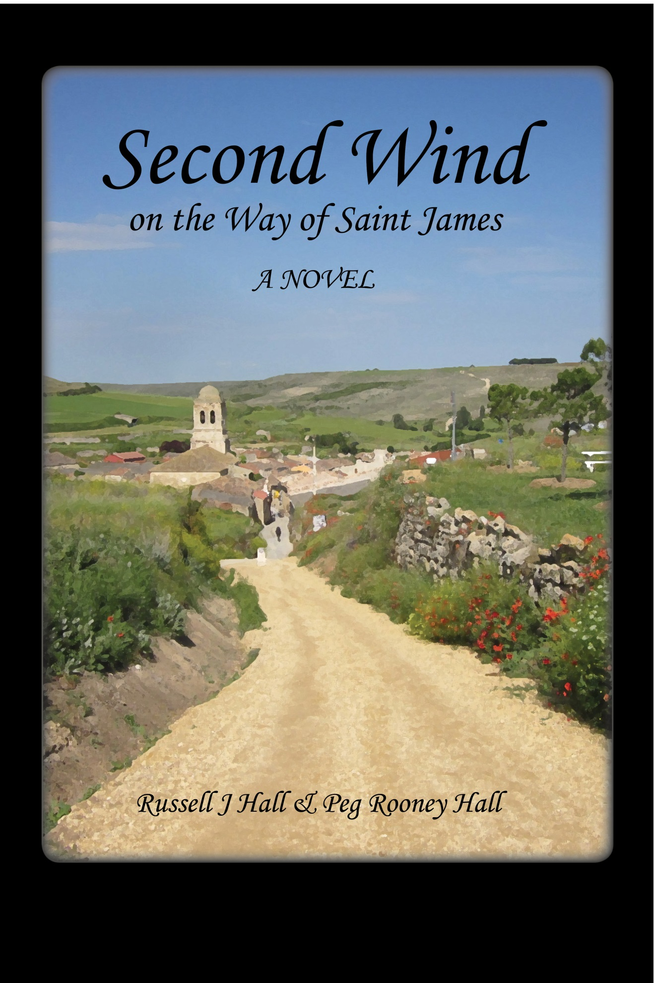

Second Wind on the Way of St. James
© 2013 by Russell J Hall and Peg Rooney Hall
Published by: Lighthall Books
P.O. Box 357305
Gainesville, Florida 32635-7305
http://www.lighthallbooks.com
Orders: gem@lighthallbooks.com
No part of this book may be reproduced or transmitted in any form by any means, either electronic or mechanical, including photocopying, recording, or any information storage and retrieval system, except as specified by the authors. Electronic versions made available free of charge are intended for personal use, and may not be offered for sale in any form except by the authors. Excluded from copyright are the maps, which are based on the work of Manfred Zentgraf of Volkach, Germany. Like the original, our adaptations of his map remain in the public domain.
Second Wind is a work of fiction. Many experiences of the authors on the Camino have inspired and informed themes of the book, but people and events depicted are products of the authors’ imaginations; any resemblance to real persons living or dead is purely coincidental.

Episode 8
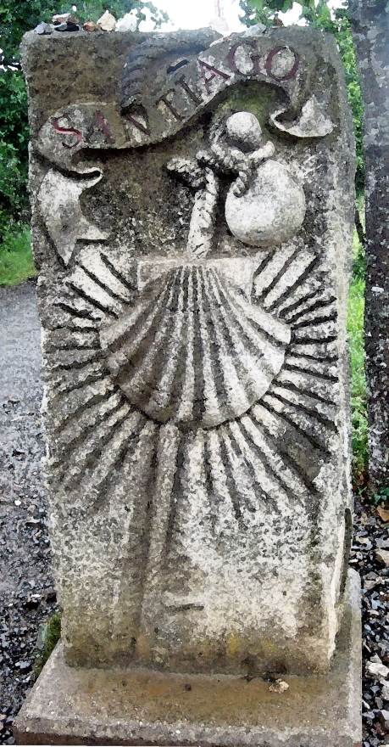
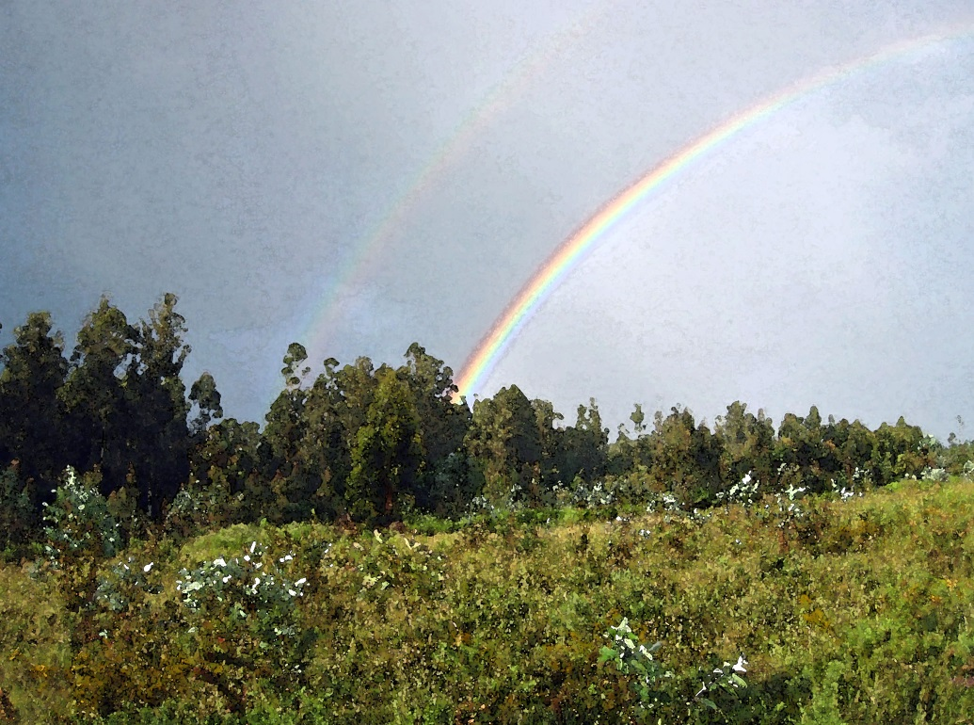

Stage Eight: Santiago
Santiago de Compostela
Sunday, June 26 – Monday, June 27

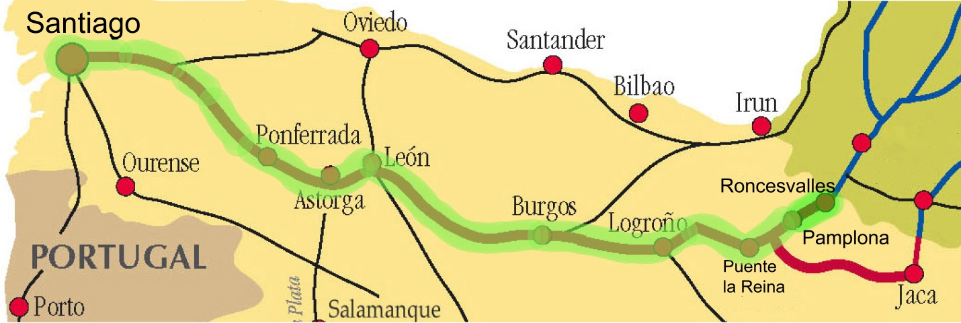
Welcoming the Future
Santiago de Compostela
Sunday, June 26 and Monday, June 27
They arrived in Santiago in the rain. “If you haven’t been to Santiago in the rain, you haven’t been to Santiago,” said Helen, smiling as she repeated what Jeanne had told her in one of their first conversations about the Camino. So, indeed they had arrived.
It had rained their entire last day of walking. She found the scenery to be unremarkable, except for a triple rainbow overhead as they were in the vicinity of the airport and approaching the city. Somehow that captured the day’s feel—anticipatory and beautiful in a highly elusive way.
Near the edge of the city they had posed at a stone monument announcing arrival in Santiago while a helpful stranger snapped their picture with Bert’s camera. The image on the camera’s small screen showed them rain streaked and bedraggled and was neither a great photo nor flattering to either of them. But Helen didn’t care. They were smiling. The picture accurately reflected her joy, and how at peace she felt with their togetherness today.
They continued through the outer and inner suburbs, and were soon in sight of the looming spires of the cathedral. Winding through the streets of the old city, she was surprised when they suddenly arrived in the Praza de Immaculada and caught sight of the northern façade of the cathedral. It was early, not yet eleven in the morning, and they were here already.
The plaza was immense, perhaps a hundred yards in each dimension, and this was only one side of the cathedral. The structure’s Baroque ornateness was decorated in lichens and moss on this north-facing side, she noticed.
They stopped near the center of the wet plaza. She had expected from the accounts of seasoned pilgrims that she would have mixed emotions about arriving here. It was true. She was sorry it was over, even though she was happy they’d made it all the way. But even the looming end of their Camino could not dampen her pleasure at their new closeness. They looked at the cathedral, looked at each other, smiled, and dripping ponchos notwithstanding, hugged each other tightly and long.
Other pilgrims stood in the square, either singly or in small groups. The two of us are alone in this vast plaza, she thought, but we’re here together with all the others who are sharing this experience with us.
Still holding his hand, Helen backed away to look at the cathedral. She flung out her other arm and stage-whispered. “We actually did it Bert. What a sense of satisfaction!”
“I must be cured!” He pulled her back toward him and smiled. “I can’t wait for the first person back home to ask me what I did on my summer vacation. I’ll relish the looks of amazement it brings when I say I walked five hundred miles, all the way across Spain.”
“I can’t even remember the last time I wondered if we’d make it to the end. It had to be weeks ago,” Helen said. “Crazy as I know it is, I hate now that it’s over. How can that be? I must have lost my mind along with those inches off my waist as we walked.”
“It’s even crazier that I feel a bit deflated to be here after wishing it to be over so many times,” Bert added. “On balance, I think my feeling of loss is somewhat stronger than my feeling of accomplishment. I am certainly not ready to give up having you around all . . .”
Helen interrupted. “What? You’re not ready to be rid of me after all these days?”
“Well, maybe days, but not the nights,” he replied. “Okay, now what?”
She squeezed his hand. Pigeons waddled around their feet, undeterred by the gentle rain.
“Is your ‘now what’ an operational question, or a metaphor?” Helen asked, reviewing several options. They could set about looking for some lunch, check into the room he’d reserved in the monastery, or visit the cathedral. Or, answering the more metaphoric question, now that they had finished the Camino, they could start figuring out how to replace or recreate it.
Most importantly, she thought, how to live with its lessons?
They moved together to a bench, slipped off their packs and settled for a moment, watching the pilgrims milling around in the rain. “How can we hold onto this quietness of mind? How can we hang on to the feeling that makes it okay just to be doing what we’re doing and not having anything else to do?” She asked it with a happy sigh.
Bert apparently shared her thoughts. “Okay, now that the walking itself is over, we need to never let the spirit of Camino escape. I think the rigors and routines of the physical journey are what made the peace of mind possible. Each day we’ve walked—well, not counting those first few miserable ones—I felt the clutter in my life slipping farther away and what matters most to me coming better into focus.
“I’ll bet it’s possible that for many people when you stop walking you immediately fill up with all the old clutter. Right now, the good old job I’ve been so eager to get back to feels like it lives on another planet, not just another continent. I like this planet better. I wonder how I can carry the Camino back with me.”
“I think I can explain the Camino to my dogs,” Helen said, laughing, “but to the other inhabitants of Sandpine Key . . . not so easy. I wish I could share it with them, and I may even try. Re-entry may be harder than walking those first several days after Roncesvalles.”
“Oh, no, nothing could be harder than that!” Bert said, with a theatrical grimace. “Just look at us, Helen. Early on we wondered if we were crazy to be doing this, and now it is clear. We really are bonkers. We’re sitting on a bench in the rain, with this dreary face of Santiago overshadowing us, and feeling a palpable sense of loss that the experience is nearly over. We could be figuring out the future while drinking warm coffee somewhere.”
“And I had barely noticed!” Helen said. “Maybe the magic of the Camino is that you become one with nature. Let’s check in at the monastery, drop off our packs, and find some things to wear that aren’t quite so damp. Then let’s go get that warm coffee and figure out how to create for ourselves the future we want.”
“That’s an ambitious agenda! We better get going,” said Bert.
Checking into the monastery—the Monasterio de San Martiño Pinario— wasn’t nearly as simple as she had expected. The massive brown stone structure formed the north side of the Praza da Immaculada. They turned their backs on the cathedral, crossed the plaza, and climbed the many wide steps up to the huge wooden doors. In the not-too-large vestibule of the immense building, the first thing they saw was a huge sign announcing that the accommodations would be renovated over the next year. Bert said, “Ah ha. That’s a reason to come back next summer—to see what they’ve done to the place.”
“Let’s wait and see if we like it. Maybe the renovation is so badly needed that we’ll wish we’d reserved somewhere else,” Helen replied.
They found a man behind a window near the main entrance. He was sitting in a room not unlike a ticket booth and seemed to be dispensing keys. Working together to find a few of the right words in their still-not-good-enough Spanish, they somehow got across to him that they would be staying at the monastery and were ready to check in.
“She return soon. I call her now. Voy a llamar. ” He said first in labored English, adding the Spanish perhaps because he thought he might have gotten it wrong. “Favor de esperar alli.”
They sat on the narrow wooden bench he indicated, pulled off their ponchos and placed their packs and walking poles on the stone floor. Damp and chilly, Helen realized she was tired despite the early hour. Bert put his hand over hers on the bench and it warmed her. She thought this must be a cumulative fatigue from all their days of walking. Both stared ahead, just relaxing together without speaking. A stream of people entered and left the monastery. Most seemed not to be pilgrims. Maybe they were tourists, or locals. Nevertheless she felt a certain kinship with them.
The nun—Helen wasn’t certain she was a nun, but guessed that she must be—appeared after a seemingly long wait that was probably less than thirty minutes. Unlike the last time a nun checked them into a monastery, Helen felt at ease. And she noted no tension in Bert as they followed the nun up the six stone steps and through the massive wooden doors leading from the vestibule. If the woman knew any words of English, she wasn’t letting on. Nevertheless, she seemed adept at sign language, and without a word led them into the maze that was the monastery, walking through a massive cloister as they navigated to the corridor that led to their room.
On the way she asked Bert a question in Spanish. He seemed not to get the gist of what she was saying. Fortunately, Helen had overheard, and surmised that she was asking whether they would be taking breakfast at the monastery. Once the question was translated, both answered affirmatively.
Flipping a wall switch that dimly illuminated a long hall with dark wooden doors with transoms over them, their guide stopped at the second door on the left, put a long, old-fashioned key in the lock, and departed, after indicating—again by easy body language—that the room was theirs. The dim lighting and dark wood of the place reminded Helen of her high school.
They had not been asked to provide payment, to sign anything, to leave passports, or to do any of the other things they were used to dealing with when they checked into lodgings.
The room was spare, but had all needed features. To start with, it had a matrimonial bed. She nodded at it, catching Bert’s eye. “Well done, Bert,” she said. He smiled at her, as he too glanced toward the bed.
There was a private bathroom with toilet, shower, and thin towels no one would call fluffy. A tank hung on the wall above the toilet. To flush, you pulled the chain on the tank. It was noisy, but worked. Though far from cozy, the room was warm enough, and had adequate floor space and other flat surfaces to accommodate their clothing and gear. A floor-to-ceiling window stood in a deep alcove with a stone bench along each side. Its dark wooden shutters matched the window sashes. They put down their packs and poles. Coffee was still calling to them, but the warmth of the room won out over it.
“I think we’re lucky to have come before the renovation,” Bert said.
“It has a certain medieval charm,” Helen replied. “It seems perfectly Santiago. Maybe we should rest awhile before going out again.”
“Good idea,” he said, as he peered out at the raindrops that had begun to blow hard against the fogged over window. “We have all day tomorrow here, too, so there’s no hurry.”
They hung up their wet ponchos and lay their damp shirts and pants on the radiator. He stretched out on the bed and gestured her down next to him. He grabbed the blanket folded on the bottom of the bed and pulled it over them against the damp cold. Having him close was a wonderful feeling. Relishing the feel of their bare arms and legs touching, she relaxed against him. Later would be less relaxed and even warmer, she thought and smiled to herself. Now, she delighted in their anticipatory midday nap.
Helen was sitting on the window bench, leaning against the wall and watching him when hunger finally got to Bert and he opened his eyes. “You look great, Helen. Maybe we should just stay here the rest of the afternoon.”
“The rest of the afternoon will be plenty long enough for everything,” she countered. “Tonight we can eat on Spanish time instead of pilgrim time.”
The rain had stopped at least for the moment and they walked to a café-bar overlooking the two-tiered Praza da Quintana on the east side of the cathedral. They watched the pilgrims in the plaza while waiting for their pizza and café con leche. But the call of being together back in the monastery made for a quick lunch, and then a lovely long afternoon.
Hours later, in twilight, they ventured out in the humid air. They found a cozy restaurant and ordered a nice, decidedly non-pilgrim dinner featuring local seafood. The wine arrived quickly and seemed especially good tonight.
“You know, I think Santiago is not the ending,” Bert said. “It’s the beginning of something—the beginning of a new camino . . . and of the new us. This afternoon, tucked snug in our room, safe from outside forces, I felt a sense of intrigue about the future. I can’t remember the last time I felt that way”.
After the waiter brought their ensaladas mixtas, Helen picked up the conversation.
“We do seem to be at turning points in our lives, and we don’t know just where to turn. My life feels a bit like our arrival in Santiago. I keep thinking about what’s next.”
Bert evidently saw an opening. “You know, I’ve been thinking about that phone call you got from Washington and how much it has weighed on you. I have known several people in the refuge division who got assigned to headquarters. They usually stayed there only two years or less. Most of them were being groomed for more important jobs, and as soon as they have learned the ropes and have a better sense of how the division operates, they’re back out in the field.”
“I guess I knew that, but it’s good to be reminded. I’ve been thinking about it too. Like you said a minute ago―the future looks different to me after our Camino. The future I have begun to think about is bigger than what I had been envisioning. I’ve done pretty well adjusting and adapting to the Camino’s demands. I feel so happy with where it has brought me. It makes me think―bring on tomorrow! Whatever it hands me, I can deal with it.”
And if it handed her a couple of years in Washington, she felt confident Bert would like having her there, where they could spend more time together. That idea pleased her. If headquarters insisted, there would be a way to make it work.
Clearly energized by the drift of the conversation, Bert joined in. “Remember before we left home and were talking about packing. My list included things like a first aid kit, extra flashlight batteries, four pairs of socks, a heavy long-sleeve shirt in case of a cold snap. You had heard that the way to travel lightly and comfortably was to go through your packing list, and leave out your fears. Can’t you see it? As we’ve been walking, we have been casting off our fears—fears that people will reject us, fears of failure, and fears that growing our relationship will lead to conflict. We left those awful burdens behind and it lightened our spirits, like our packs were lightened.”
She was grateful they were in the kind of restaurant that expects you to take all evening to eat and even to stay and relax after your meal. She was sure their waiter wouldn’t even think of hurrying their evening. They watched and smiled as he set a plate of mixed cheeses and chorizos before them. Bert ordered a new bottle of wine.
“Well, we did think we might turn into philosophers by the time we got here,” said Helen. “And that sure sounded like something only a philosopher would say. Really, I believe we’re each on a much better track than we were when we started this adventure. But there is still the question of us—as in the two of us. Where are we going?”
“Let me pour us some more wine before I tackle that one,” said Bert.
“I just noticed how beautiful the plaza looks behind you in the moonlight. We’re so lucky to be here, Bert. Maybe we don’t need to answer all the questions tonight. We can just sit here and enjoy what the Camino has given us.”
He raised his glass to her.
When they had finished their wine, he reached for her hand. They paid up and walked out. The moon had disappeared and the rain had returned. Beyond talked out, they crossed the plaza leaning into one another in comfortable silence as they walked to the monastery. In the quiet she felt they were trying to get a sense of their unfamiliar new souls.
__________
They woke to another rainy day, their second and last in Santiago. They joined other monastery guests in the basement dining room for a modest meal of coffee, bread, cheese, and thin slices of meat. They didn’t stay long, however. They had two goals for the morning: to get their Compostelas at the Pilgrim Office, and to go to the mass at noon at the cathedral. They hoped to bump into some of the other pilgrims they’d met along the way.
Fully expecting a long line of people waiting to show their passports and get their certificates of completion, they stepped into a short one. It did snake up the stairway ahead of them, but they did not have to stand outside in the rain to wait. It was early and today’s arriving pilgrims were still on the trail, so they waited only with those who like them had come in yesterday. They scanned the crowd for familiar faces but didn’t spot any friends ahead of them.
When their turn came, after thirty minutes of inching up the wide, stone staircase behind those who had arrived earlier, they stepped before a long desk. Each faced an official who examined pilgrim passports to ensure that they had stamps to show they’d walked at least the required one hundred kilometers. They answered a series of questions to give the office data on what country they were from and why they were walking the Camino. They walked out with their Compostelas ornately inscribed in Latin, and stowed in cardboard tubes so they could arrive home unwrinkled and ready for framing.
As they started back down the steps, there waiting in line were the Spanish brothers Oscar and Ernesto. They had handshakes for Bert and hugs for Helen. They all promised to watch for each other later when they weren’t holding up traffic on the stairs.
They had been at the Pilgrim Office less than an hour and still had some time before mass. It wasn’t raining for the moment, so they grabbed the opportunity to walk through all four plazas, on the four sides of the cathedral. Beginning on the south side near the pilgrim office, they walked past the fountain with horses jumping out of water which Federico García Lorca nicknamed "The Fountain of the Dream" in one of his poems.
On the east side, they walked slowly up the broad bank of steps separating two plazas, the square of the dead, below—once apparently the site of a cemetery—and the square of the living, above. Just past the bar where they’d had pizza yesterday, they entered their own Praza de Immaculada, in front of the monastery. A string quartet—two young men and two women—was playing in the center of the square. The sign before the musicians indicated they were from Russia.
They ended up on the west side in the Praza do Obradoiro and asked a young man to take their picture. This was the scene featured in all the guidebooks, and each wanted a good copy to hang when they got home. Barely out of earshot of the string quartet, they heard harsher musical notes, and spotted a man playing Galician bagpipes.
They saw the Hostal de los Reyes Católicos on the north end of the square. It had been hosting pilgrims since the Middle Ages and now had become so upscale that it didn’t interest Helen at all, not even just to peek inside. She got no argument from Bert about foregoing a visit.
Having circumnavigated the whole cathedral, they entered through the west doorway. They found the Tree of Jesse, a column where for centuries pilgrims had placed a hand, and noted the indentations all those hands had made in the stone. Recently it had been covered by a clear plastic shield for the column’s protection.
They watched as pilgrims filed up a stairway that led past the back of the statue of St. James above the altar and, following tradition, placed a hand on its shoulder. Neither of them was inclined to join in the ritual.
Earlier Helen had decided she preferred Romanesque simplicity, but, after all, this was the end point of the Camino. She wanted to build a memory of the cathedral that would last. It helped her to have read that the structure was built following a simple Romanesque design, but in later centuries exterior faҫades and the interior were decorated with the complex flourishes of the later Gothic and Baroque architectural styles. She was quite sure no photos would tell the ornate tale adequately.
They had arrived at the cathedral a full hour before mass was to begin, and spent a half hour on their little tour. That was enough for them. By then the building was already filled. They stopped in the entry of the north transept where they thought they might be able to see a bit of the mass. Across the crowd, thankfully far away, Helen spotted Trudi and Heinrich, the Friend Collectors, and pointed them out to Bert.
When the mass began, they could hear everything. The cathedral was equipped with excellent electronic acoustics. Only rarely, however, could Helen see the celebrants through the crowds. They remained until the mass was over, and remarked as the crowds were filing out that neither had found special interest or inspiration in the service. It just felt right to be there, where centuries of peregrinos had been before them.
Helen felt a hand on her shoulder and turned to find herself looking into Ilsa’s big grey eyes. They hugged, and then Bert said he wanted a hug too. Never a natural hugger herself and certain that Bert wasn’t one, Helen marveled at how their Camino experience seemed to be converting both of them. He asked Ilsa how the final days of her Camino had gone, and her eyes smiled along with the rest of her face. She said she could not really have asked for more from it. As they walked out together, Helen surprised herself telling Ilsa that she thought she and Bert had perhaps begun to find the walls of their cages and push them down. Ilsa wished them well as she hurried off to catch a train to Madrid.
They slipped into a café and ordered a coffee to drink while they watched the rain that had begun again just as they left the cathedral.
“Now that it is siesta time,” Bert said, “all the museums in town will be closed until five or so. I don’t feel too disappointed to be missing them. Even if we had time to see all the sights, I still don’t think I would regard Santiago as a real highlight of our Camino. It just doesn’t do much for me. Arriving was an anticlimax. After our wonderful conversation last night, my abyss has almost faded away. Today the feeling that we are at the beginning of the future has set in with a vengeance.”
Helen pulled her eyes back from the window where she’d been watching the pilgrims going in and out of the cathedral. She put down her cup and looked straight at him.
“What a nice thought, Bert. And, I agree with you about Santiago. But I guess I’ve never thought about making a list of Camino highlights. The parts I liked best weren’t places. They were more things like seeing Ilsa sitting in the rain writing in her journal under her poncho and having Raymond say that pilgrims are seekers, more than pray-ers. I guess the highlights for me were the magical moments.”
“Well said.” Bert added, “I list fluffy-towel Robert’s twenty percent Camino using his twenty percent heart―and, reserving that cama matrimonial.”
“Oh, yes, your figuring out how to do that was a definite highlight,” Helen replied with a broad smile. “That was a banner day in your improving mastery of the Spanish language.”
“Right. My Spanish.” He raised his coffee cup and clinked it against hers. She held his blue eyes in her gaze.
“Back to the point.” He sat back in his chair.
“So, saying that Santiago is not a highlight, it’s not a criticism of the city. It’s about us,” Bert added. “Santiago might delight us if it we weren’t sad to be at the end of our Camino. Maybe we’d love it if we knew where the changed Bert and Helen were going from here.”
Helen’s eyes still were shining as she looked over the cup in her hands and smiled.
“Well, the changed Bert and Helen aren’t going back to where they were—not if I have anything to say about it. I like the new us. We have more fun,” she said. “I like the change I see in you at the end of your Camino. And it’s not just that now you pull me into your bed as often as we can find the opportunity. I like that you are happier.”
“I’m not so sure it isn’t all about pulling you into bed. But really, Helen, you are perceptive as always, and righter than you could have guessed. Remember asking me what happened when I came down from the Cruz de Ferro?”
“Sure do. Is it time to ask you again?”
“It is. Well, when I got up to the cross, I spotted a wallet. I thought somebody must have dropped it, so I looked inside. It was empty except for a note in Spanish that said something like that old safety slogan―you know, ‘Drive carefully; the life you save may be your own.’”
“Ha! I haven’t thought of that saying in a long time,” she said.
“Honestly, the minute I read it I realized that I have to be the one responsible for saving my own life―for figuring out how to stop looking at the future as an abyss and start making it a place I want to be. The scary part was, at the Cruz de Ferro, I realized that all along I had been hoping you would find a way for me to avoid that abyss. And you weren’t doing it.
“The sudden realization that I had to take control of my life made me understand why you couldn’t do it for me. How could you? Your life had most of the same problems as mine—no friends or family to speak of, no hopes or dreams for the future—and that was even before I knew about the call from Donald that was weighing on you. I realized that I couldn’t change things for you any more than you could for me. We each had to fix . . . to save our own lives.”
“I really had been trying to help you,” Helen interrupted. “I told myself that the Camino would be good for you. That’s why I was so insistent you come. Or that’s what I thought at the time. But I guess you’re right that I couldn’t really help. And one of the things the Camino has shown me is that trying to help other people all the time is for me a bit of a cop out that keeps me from facing my own problems.”
“I have to say that your facing some of those demons is one of the keys to my happiness right now. I was afraid that if you couldn’t come to grips with your fears and couldn’t trust yourself more, our friendship might not make it. I couldn’t bear the thought of leaving it, and you, behind. But, instead, the Camino worked its magic on both of us. You really have changed too,” he said.
“Come on, Bert. I don’t think I have changed much at all—other than that business about your bed, I mean.” She pushed the hair back from her eyes. It was getting too long after all these weeks.
“I love that new way you have of seeming vulnerable and competitive simultaneously,” Bert said watching her. “Maybe we’re not so different at all.”
“How so?,” she asked.
“We were both affected by Ilsa’s talk about living in cages of our own making. I had to take more responsibility for my abyss. You had to believe that when you let others know you well, they would love you and not reject you. You feel me being happier, and I feel you trusting more, at least in me. What if you let your sisters into your life more too?”
“Hmmm, I hadn’t thought about them that way. Yeah, maybe,” Helen replied. “It could be my first assignment for our future.” She laughed.
“Oh no! Assignments already! Could you stop being so organized!” Bert laughed too.
They finished their coffee and decided to visit the small museum in the cathedral. They had learned it was the only one open during siesta, and they would try to make it last through a good part of the afternoon.
Then they would rest, together. The laziness of Santiago in the rain, the fatigue born of day after day of relentless walking, and the magic of the Camino-induced changes in their lives called them to celebrate.
Later they were again sitting on one of the benches in the monastery’s vestibule, hoping to catch the nun. They owed her at least sixty euros, and Bert said he was afraid they would have to leave Santiago before they found an opportunity to pay up. After they saw her, they needed to find an Internet café so they could proclaim their success to their friends.
Helen was pensive. “Despite what I said earlier about not letting the changed Bert and Helen fade away, I’m a bit afraid,” she said.
A cluster of children, probably a middle school class, filed into the monastery, leaving a trail of wet footprints on the gray stone floor. When they disappeared into the interior, Helen continued.
“I wonder if the magic of the Camino is powerful enough to protect us from the influences in our old lives.”
“I think it is,” Bert replied. “But before I tell you why, Helen, I’m going to be a hard ass and ask you a question I bet you can’t answer.”
“Try me, oh you of little faith.”
“Just what is the magic of the Camino? Use as many words as you want.”
Her face lit up the way it did when she was creating the fairytale about the frog and the princess at the café-bar in El Burgo Ranero. She began by recalling a magic show she saw as a child, where the magician did a spectacular trick, appearing to swallow a fluttering bird. Amazed and delighted she asked him. How did you do that? With a twinkle in his eye and a slight bow, the magician replied, “magic.”
“The point,” she said, “is that once you have taken apart and analyzed something magic, it isn’t magic anymore.”
“No fair! That’s not an answer! Now, I’ll tell you the real answer,” Bert said. “There’s nothing magic about the Camino. After all, it’s just a road we’ve chosen to walk down. I believe the magic is in us, and all the Camino did was get us so unbalanced that we couldn’t help but stumble over it.”
“That’s good, Bert. Was the Camino just a wonderful adventure? It was that, but if you ask me, it also made us come to grips with things that were holding us too close to our past. It made us want to take charge of our future. It’s put us at the beginning of a new trail. Taking the first steps onto it is as scary, thrilling, and exhilarating as it was to start out in Roncesvalles.”
“I’m not reluctant this time, Helen,” Bert said. “We can do this.”
“If you’ll help me, I’ll help you,” Helen said.
“How can I resist an offer like that?”
Their plane for Madrid would leave at ten the following morning.
__________
June 27, 2011 5:42 PM
From: Helen.Morgia@southnet.com
To: Maureen327@midnet.net, Donna121@midnet.net
Subject: Camino magic
Sisters,
I think I have begun to figure out what’s different and what I want to be different. Let’s plan a getaway weekend together, okay? I need some sister time with you.
The Pilgrim Sister
____________
June 27, 2011 5:45 PM
To: task_force_alpha@doe.gov
Cc: Maureen327@midnet.net, Donna121@midnet.net
From: bert_task_force_alpha@doe.gov
Subject: Final Camino Report SANTIAGO!
We made it! We have walked 790 kilometers, which is roughly 490 miles, and we are now in Santiago de Compostela. It took us 43 days, which calculates to nearly 11 ½ miles a day, counting our rest days.
Our bodies may never recover. And you, dear friends, may never recover the same old Bert and Helen you knew and loved so well.
B & H

